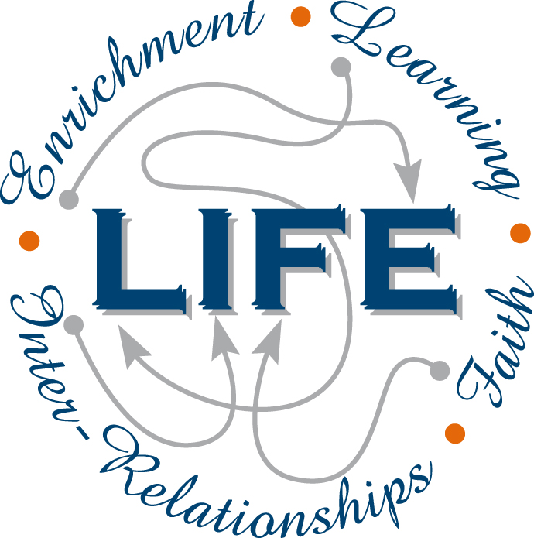
12 PHYSICS
ASSESSMENT OUTLINE 2016

Assessment type | Assessment type weighting | Assessment  task  weighting | When | Assessment task
Science  inquiry | 20% | 5% | Spring Term  Week 8 | Experiment – measuring the magnetic field strength of the Earth, force on a wire.
 |  | 5% | Summer Term  Week 8 | Investigation - circular motion.
 |  | 5% | Autumn Term  Week 6 | Investigation - moments and equilibrium.
 |  | 5% | Autumn Term  Week 8 | Evaluation and analysis – quantum theory and relativity.
Test | 30% | 3% | Spring Term  Week 9 | Electromagnetism.
 |  | 4% | Summer Term  Week 5 | Electromagnetic induction.
 |  | 4% | Summer Term  Week 9 | Projectiles and circular motion.
 |  | 4% | Autumn Term  Week 2 | Gravity and torque.
 |  | 5% | Autumn Term  Week 9 | Wave particle duality and quantum theory.
 |  | 5% | Winter Term  Week 3 | Special relativity.
 |  | 5% | Winter Term  Week 8 | Standard Model
Examination | 50% | 22% | Autumn Term  Week 4-5 | Semester 1 Examination.
 |  | 28% | Winter Term  Week 10 | Semester 2 Examination.
Total | 100% | 100%

